

PROJECT NAME

API TEST PLAN

This document has been created and submitted on a confidential basis solely for the benefit of the intended recipient. It may not be reproduced or copied in any form. By accepting delivery of this document, the recipient acknowledges and agrees that:

- the recipient will not copy, fax, reproduce, or distribute this document, in whole or in part, without permission

- all of the information contained herein will be treated as confidential material

Confidential and Proprietary
Company Name

Project Name
Document Name | Test Plan

Author: |  |  |  | Reviewer: |  |  |  | Approver:
Signature |  |  |  | Signature |  |  |  | Signature
Electronic copies valid without signature

Document Version History

Version Number | Effective Date | Nature of Modification
0.1 | 02/10/2021 | Initial draft of Test Plan
0.2 | 03/10/2021 | Incorporated Test Manager review comments
0.3 | 06/10/2021 | Incorporated Client review comments

Document Distribution

This document will be directly distributed to the following individuals.

Name of the Receiver | Role

Table of Contents
1. INTRODUCTION 4
1.1 PURPOSE 4
1.2 SCOPE 4
1.3 DEFINITIONS, ACRONYMS & ABBREIVIATIONS 5
1.4 REFERENCES 5
1.5 PRE-REQUISITES & ASSUMPTIONS 5
2. FEATURES TO BE TESTED 5
3. FEATURES NOT TO BE TESTED 6
4. TESTING RISKS 6
5. TEST STRATEGY 6
5.1 TEST APPROACH 7
5.2 TESTING TECHNIQUES 7
5.2.1. USER REQUIREMENT TESTIING 7
5.2.2. SMOKE TESTING 7
5.2.3. COMPATIBILITY/BROWSER TESTING 7
5.2.4. SYSTEM TESTING 8
5.2.5. ADHOC TESTING 8
5.2.6. EXPLORATORY TESTING 8
5.2.7. USABILITY TESTING 9
5.2.8. REGRESSION TESTING 9
5.2.9. RETESTING 9
5.2.10. API/INTEGRATION TESTING 9
5.2.11. FUNCTIONAL TESTING 10
5.2.12. END TO END TESTING 10
5.2.13. USER ACCEPTANCE TESTING 10
5.3 TEST CASE DESIGN 10
5.4 DIALY TRIAGE MEETINGS 11
5.5 INTERNAL RELEASE CRITERIA 11
5.6 TESTING WORKFLOW & TESTING CRITERIA 11
5.7 TEST PHASES/STLC 12
5.8 TEST CASE EXECUTION 12
5.9 TEST TOOLS 12
5.10 TEST SCHEDULE 13
5.11 BUG TRACKING & REPORTING 13
5.12 BUG SUMMARY REPORT 13
5.13 BUG LIFE CYCLE 13
5.14 BUG(s) CLASSIFICATION 14
5.15 TEST STATUS REPORTING 14
6 TEST ENVIRONMENT 15
7 RELEASE CRITERIA 15
7.1 TEST PASS & FAIL CRITERIA 15
7.2 TEST SUSPENSION & RESUMPTION CRITERIA 15
7.3 EXTERNAL BUILD RELEASE 15
7.4 UAT CRITERIA 15
8. TEST DELIVERABLES 15
9. ROLES & RESPONSIBILITIES 16
10. ANNEXURE(s) 17

INTRODUCTION

PURPOSE
The purpose of this document is to explain the API testing methodologies for project application which will be used by the end user. It lays out an entire plan and test strategy that would be conducted to evaluate PROJECT- application requirements and deliver the application with quality.

This document shall be maintained throughout the project test life cycle and shall be kept up to date to reflect the actual accomplishments and testing plans of the project. The intended audience for this document will be all the stakeholders of PROJECT- web client application.

This Test Plan supports the following objectives:

- What to Test, Who to Test, When to Test, How to Test
- Communicate to all responsible parties on various dependencies and risks
- Describe the appropriate testing strategies, process, workflows and methodologies
- Describe the plan to organize, execute and manage testing of the AUT
- Define bug tracking & reporting procedures
- Identify required test resources
- Provide Testing Schedule, Testing Deliverables

SCOPE
The testing scope is defined in terms of test approach, system environment setup, designing test cases, test execution, bugs reporting, tracking and closure. After understanding and analysing PROJECT application requirements, following testing techniques are proposed to test the web client application:
FUNCTIONAL TESTING

- Smoke Testing/Positive Testing
- Retesting
- Negative Testing
- Interoperability Testing
- API Integration Testing
- API Mocking Testing
- API Assertions Testing

NON-FUNCTIONAL TESTING

- Security/Vulnerability Testing
- Performance/Load Testing

DEFINITIONS, ACRONYMS & ABBREIVIATIONS

Abbreviation | Description
AUT | Application Under Test
SRS | Software Requirement Specification
QA | Quality Assurance
QC | Quality Control
TSR | Test Status Report
UAT | User Acceptance Testing
NA | Not Applicable
BBT | Blackbox Testing
V&V | Verification and Validation

REFERENCES
S.No. | Document Title | Document No. | Version | Author | Released Date
1
2

PRE-REQUISITES & ASSUMPTIONS
- QA shall have only 1 latest build to refer for testing
- This document assumes that all kind of tests, which are mentioned in this document will be conducted to evaluate the fulfilment of the application with specified requirements
- In case of requirement changes, the test plan will be reviewed and updated
- Unit Testing & Dev Integration Testing are conducted by Development team before initiating a build release to QA
- Every release to QA will accompany an internal release notes from Development team specifying the details of the features implemented and its impact on the AUT, only after concluding Unit Testing & Dev Integration Testing as PASSED
- All P1 bugs shall receive immediate attention from the development team
- All bugs found in the application version will be fixed and unit tested by the development team before the next version is released to QA for further rounds of testing and the SLA could vary between 3 working days to 5 working days
- All the API documentation shall be up to date and delivered to QA
- For UAT initiation, the project team must have completed Unit, Integration and System testing and met all the Business Requirement’s, based on RTM (PM approval required)

API TESTING OBJECTIVE
The main goal of API test strategy is to agree on how to automate both integration and [if necessary] unit level test harness in order to:

- Prove implementation is working correctly as expected, i.e. bugs
- Ensure implementation is working as specified, i.e. according to requirements specification
- Prevent regressions in between releases
- Below are our test scenarios categories as part of API testing objectives:

- Basic positive tests (happy paths)
- Extended positive testing with optional parameters
- Negative testing with valid input
- Negative testing with invalid input
- Destructive testing
- Security, authorization, and permission tests (which are out of the scope of this post)

FEATURES TO BE TESTED
Integration Requirements

FEATURES NOT TO BE TESTED
Integration Requirements
Any other features/requirements outside the integration requirements/use-cases will not be tested

TESTING RISKS
S. No | Risks | Mitigations
1 | Schedule slippages | Extra Testing (Execution) Hours
2 | Network Problem | Switch Network Connectivity to  Wi-Fi/LAN/4G
3 | Lack of Clear Requirements & API Documentation | Frequent interactions amongst the project teams
4 | Testing Environment unavailability | Test in the Dev environment
5 | Unavailability of builds on time as per the signed off project plan | This should be notified in advance so that Testing activities can be planned in an effective way. Testing timelines, if required, might have to be extended.
6 | Undocumented requirements or lack of clear communication to QA team | A review meeting has to be scheduled with QA team in order to update the recent changes and the same should be documented regularly. This activity has to be performed prior to the test case design/execution

TEST STRATEGY
The purpose of Test Strategy is to identify the major tasks and the approach to test the project application. To achieve the goal, QA team would follow the below practices:
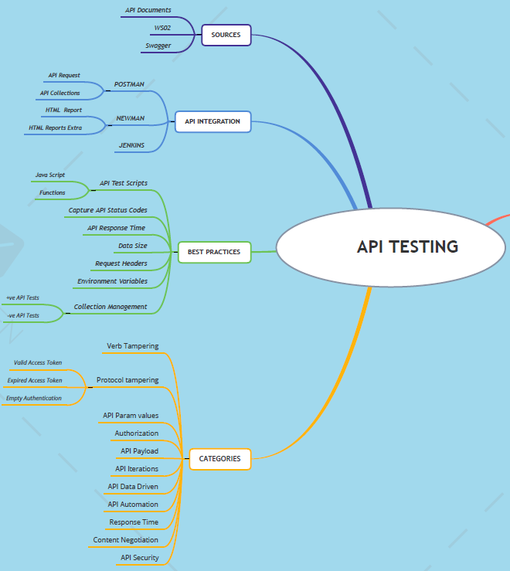

TEST APPROACH
The project application shall be API tested by simultaneously applying the below mentioned API testing techniques:

TESTING TECHNIQUES

SMOKE TESTING/POSITIVE TESTING
Participants:
QA team will be responsible for conducting Smoke Testing or Positive Testing of the APIs using Postman tool
Methodology:
This will be carried out by executing the developed APIs to achieve the integration capability between the front end and back end applications. If all the API test cases are PASSED, only then the build is considered for further exhaustive round(s) of testing else the Smoke Testing would be failed and build rejected.
- Verify correct HTTP status code. For example, creating a resource should return 201 CREATED and unpermitted requests should return 403 FORBIDDEN, etc.
- Verify response payload. Check valid JSON body and correct field names, types, and values — including in error responses.
- Verify response headers. HTTP server headers have implications on both security and performance.
- Verify basic performance sanity. If an operation was completed successfully but took an unreasonable amount of time, the test fails.
S.No | Entry Criteria | Exit Criteria
1 | Formal build is released to QA by the development team | Basic functionality (Positive Testing) of the AUT is working as expected
2 | Successful completion of Unit Testing & Developer Integration Testing by Dev team | No visible or direct application crashes (P1 bugs = 0) are discovered during Smoke Testing
3 | Internal Release Notes is submitted with features implemented & known bugs, if any | Smoke Testing is concluded as PASSED after execution of all P1 Smoke Test Cases
4 | API Smoke Test Cases are ready & signed off after a review by Project Team | Not more than 2 P2 functional bugs are detected @ Smoke Testing

NEGATIVE TESTING
Participants:
QA team will be responsible for conducting API Negative Testing using Postman tool
Methodology:
This is conducted by testing the developed APIs against the negative workflows as identified below:
- HTTP Verb/Method tampering
- HTTP Protocol tampering
- Query Parameters tampering
- Access Token tampering
- Refresh Token tampering
- Authentication tampering
- API Request Payload changes
- End Point tampering
- Verify that the API returns an appropriate response when the expected output does not exist.
- Perform input validation test.
- Verify the API’s behaviour with different levels of authorization.
- Attempting to create a resource with a name that already exists.
- Attempting to delete a resource that doesn’t exist.
- API calls with invalid input.
- – Missing or invalid authorization token (includes other Authorization/Authentication methods).
- – Missing or invalid query parameters (required and optional).
- – Payload with an invalid model.
- – Payload with an incomplete model (missing fields or required nested entities).
- – Invalid values in HTTP headers.
- – Unsupported methods for endpoints.
Following areas are tested on input:
- Wrong (not accepted) values in input parameters
- Empty values in input parameters
- Too many parameters
- Too few parameters
- Inconsistencies on stated parameters and actual data (wrong document type)
- Case insensitivity on parameter names
- Empty request

PERFORMANCE/LOAD TESTING
Participants:
QA team will be responsible for conducting Performance Testing of APIs using Postman tool
Methodology:
The main objective is to find the capacity limit point of the whole system: the uppermost limit in terms of load in which, system behaves within the acceptable range, that is in terms of response latency, and number of successful transactions. Then use this point to do capacity planning and to define SLAs.

This is conducted by using Postman tool for all the developed REST APIs and business transaction work-flows identified and tested against the benchmarks provided for each business work-flow by the product owner, as per below:
To ensure the API can handle the expected or higher load, QA engineers validate its functionality and performance by artificially creating or simulating API calls. We’ll outline the types of API performance testing.
Load testing. The point of load testing is to measure where the limit of system performance under high load lies. That’s why we measure response times, throughput, server conditions, etc., while increasing the number of calls.
Soak testing. Load tests that run over a long period of time can reveal system instabilities like API memory leaks. So when you have a weekend ahead, leave automated soak tests running. On Monday, it will show you whether any unwanted behavior has emerged.
Stress testing. The idea is to gradually increase the count of virtual users to find the point at which the API starts throwing errors, slows down, or stops responding.
Spike testing. Contrary to stress testing, here an API undergoes a sudden spike of users. Spike testing checks whether the API is able to stabilize and return to normal functioning after that.
Scalability testing. You want to be sure that your system performance scales according to the changing load. To do so, increase the number of incoming requests and monitor whether it causes a proportional increase in response time.
Peak testing. Similar to soak testing, here you subject your API to the heaviest load while reducing the time of the attack.

INTEROPERABILITY TESTING
Participants:
QA team will be responsible for conducting Interoperability Testing of APIs using Postman tool
Methodology:
This is conducted by testing the APIs using different USER-AGENT strings in Request Headers to see how the APIs behave when the request is initiated from different OS and different browsers versions and different mobile devices.

SECURITY/VULNERABILITY TESTING
Participants:
QA team will be responsible for conducting Vulnerability Assessment Testing of APIs using Postman tool and Burp Suite tool
Methodology:
This is conducted by using Postman tool for all the REST APIs and the application work-flows and will identify the application vulnerable areas by injecting required payloads.

Security, penetration, and fuzz testing are the components of the security auditing process aimed at testing an API for vulnerabilities from external threats.

Security testing. It validates whether security requirements are met. This includes authentication, permissions, and access controls, namely:

- What type of authentication is required to use the API;
- How well sensitive data is encrypted;
- What authorization checks are set for resource access, etc.

Fuzz testing. The last step in the security audit tests the API at its absolute limits. Forcibly inputting massive amounts of random data, it tests whether the API will stand it or end up with negative behavior like a forced crash or overflow.

- Check that the API is designed according to correct security principles: deny-by-default, fail securely, least privilege principle, reject all illegal inputs, etc.
  - Positive: ensure API responds to correct authorization via all agreed auth methods – Bearer token, cookies, digest, etc. – as defined in spec
  - Negative: ensure API refuses all unauthorized calls
- Role Permissions: ensure that specific endpoints are exposed to user based on role. API should refuse calls to endpoints which are not permitted for user’s role
- Protocol: check HTTP/HTTPS according to spec
- Data leaks: ensure that internal data representations that are desired to stay internal do not leak outside to the public API in the response payloads
- Rate limiting, throttling, and access control policies

RETESTING
Participants:
QA team will be responsible for conducting Retesting of fixed APIs using Postman tool
Methodology:
This is conducted by re-executing the failed API Test Cases and the resolved bugs after the bug fixes are delivered in a new build release to QA and the following steps are involved:
- Refer the Internal Release Notes published by Dev team for the bugs resolved/fixed in the new build
- Retest all the resolved/fixed bugs on the new build
- Reopen/Close the bugs as per the retesting status
- Publish Retesting test report, in the prescribed format

API MOCKING TESTS
Participants:
QA team will be responsible for conducting API mock tests, if needed.
Methodology: Mocking Target systems may help automate testing and is recommended in following scenarios:
- When target APIs are not mature or reliable enough
  - Availability of target APIs - deployment, migrations, lifecycle-impedance
  - When target APIs are being developed at the same time as Apigee proxies - create independent and parallel development streams for target APIs and Apigee proxies
  - There are network, systems, data stability or maturity issues
- When data is constantly changing or nature of data is such that it is not predictable to be asserted consistently using automated testing
- When it is not possible (or very difficult) to simulate certain scenarios for testing purposes
  - 5xx errors from target
  - timeouts
  - data collisions, conflicts
- When tests rely on previous data population, e.g. user change password, reset, duplicate email, forgot password cases
- Target API has bad response times, e.g. API that responds in 2 minutes. We need fast tests and should be relatively cheap to execute them.

API ASSERTIONS AUTOMATION TESTING
Participants: QA team will be responsible for conducting API Assertions Testing
Methodology: Integration tests generally assert following points:
- Target request: assert parts of HTTP request Postman tool makes to target, e.g. url, headers, body, etc. This is generally done by defining a special route that hits a request mirroring mock which echo's Postman tool request back
- Postman tool response: assert parts of HTTP response sent by Postman tool to client, e.g. url, headers, body, etc.
- Data processed/output by policies that are not visible in target request or proxy response - this is generally done by collecting such data separately and echo'ing them back in Postman tool response as part of test headers.

API/INTEGRATION TESTING
Participants:
QA team will be responsible for conducting API/Integration Testing. These tests simulate an API client sending certain request combinations and assert response received from the API.
Methodology:
This is conducted by running the APIs using Postman Tool to ensure the API Response body matches with the API Request submitted for all methods defined such as GET, POST, PUT, DELETE, to expose the bugs in the interfaces and in the interactions between integrated components or systems. Focused on communication between APIs, it ensures they are well-connected and don’t cause bugs in another API’s modules.

TEST CASE DESIGN
On the basis of signed off RFP, the Test Analyst designs/updates the Test Cases, as per below generic API test case checklist:

# | Test Scenario Category | Test Action Category | Test Action Description
1 | Basic positive tests (happy paths)
 | Execute API call with valid required parameters | Validate  status code: | 1. All requests should return 2XX HTTP status code  2. Returned status code is according to spec:  – 200 OK for GET requests  – 201 for POST or PUT requests creating a new resource  – 200, 202, or 204 for a DELETE operation and so on
 |  | Validate  payload: | 1. Response is a well-formed JSON object  2. Response structure is according to data model (schema validation: field names and field types are as expected, including nested objects; field values are as expected;  non-nullable fields are not null, etc.)
 |  | Validate  state: | 1. For GET requests, verify there is NO STATE CHANGE in the system  (idempotence)  2. For POST, DELETE, PATCH, PUT operations  – Ensure action has been performed correctly in the system by:  – Performing appropriate GET request and inspecting response  – Refreshing the UI in the web application and verifying new state (only applicable to  manual testing)
 |  | Validate  headers: | Verify that HTTP headers are as expected, includingcontent-type,connection,  cache-control,expires,  access-control-allow-origin,keep-alive, HSTS, and other standard header fields –  according to spec.  Verify that information is NOT leaked via headers (e.g.X-Powered-Byheader is not sent  to user).
 |  | Performance sanity: | Response is received in a timely manner (within reasonable expected time) — as  defined in the test plan.
2 | Positive + optional parameters
Execute API call with valid required parameters AND valid optional parameters
Run same tests as in #1, this time including the endpoint’s optional parameters (e.g., filter, sort, limit, skip, etc.)
 |  | Validate  status code: | As in #1
 |  | Validate  payload: | Verify response structure and content as in #1.  In addition, check the following parameters:  – filter: ensure the response is filtered on the specified value.  – sort: specify field on which to sort, test ascending and descending options. Ensure  the response is sorted according to selected field and sort direction.  – skip: ensure the specified number of results from the start of the dataset is skipped  – limit: ensure dataset size is bounded by specified limit.  – limit + skip: Test pagination  Check combinations of all optional fields (fields + sort + limit + skip) and verify  expected response.
 |  | Validate  state: | As in #1
 |  | Validate  headers: | As in #1
 |  | Performance sanity: | As in #1
3 | Negative testing – valid input
Execute API calls with valid input that attempts illegal operations. i.e.:
– Attempting to create a resource with a name that already exists (e.g., user configuration with the same name)
– Attempting to delete a resource that doesn’t
exist (e.g., user configuration with no such ID)
– Attempting to update a resource with illegal valid data (e.g., rename a configuration to an existing name)
– Attempting illegal operation (e.g., delete a user configuration without permission.)
And so forth.
 |  | Validate  status code: | 1. Verify that an erroneous HTTP status code is sent (NOT 2XX)  2. Verify that the HTTP status code is in accordance with error case as defined in spec
 |  | Validate  payload: | 1. Verify that error response is received  2. Verify that error format is according to spec. e.g., error is a valid JSON object or a  plain string (as defined in spec)  3. Verify that there is a clear, descriptive error message/description field  4. Verify error description is correct for this error case and in accordance with spec
 |  | Validate  headers: | As in #1
 |  | Performance sanity: | Ensure error is received in a timely manner (within reasonable expected time)
4 | Negative testing – invalid input
Execute API calls with invalid input, e.g.:
– Missing or invalid authorization token
– Missing required parameters
– Invalid value for endpoint parameters, e.g.:
– Invalid UUID in path or query parameters
– Payload with invalid model (violates schema)
– Payload with incomplete model (missing fields or required nested entities)
– Invalid values in nested entity fields
– Invalid values in HTTP headers
– Unsupported methods for endpoints
And so on.
 |  | Validate  status code: | As in #1
 |  | Validate  payload: | As in #1
 |  | Validate  headers: | As in #1
 |  | Performance sanity: | As in #1
5 | Destructive testing
Intentionally attempt to fail the API to check its robustness:
Malformed content in request
Wrong content-type in payload
Content with wrong structure
Overflow parameter values. E.g.:
– Attempt to create a user configuration with a title longer than 200 characters
– Attempt to GET a user with invalid UUID
which is 1000 characters long
– Overflow payload – huge JSON in request body
Boundary value testing
Empty payloads
Empty sub-objects in payload
Illegal characters in parameters or payload
Using incorrect HTTP headers (e.g. Content-Type)
Small concurrency tests – concurrent API calls that write to the same resources (DELETE + PATCH, etc.)
Other exploratory testing
 |  | Validate  status  code: | As in #3. API should fail gracefully.
 |  | Validate payload:  Validate headers: | As in #3. API should fail gracefully. As in #3. API should fail gracefully.
 |  | Performance  sanity: | As in #3. API should fail gracefully.

Test cases derived from the table above should cover different test flows according to our needs, resources, and priorities.

DIALY TRIAGE MEETINGS
The project team calls for huddle meetings at agreed regular intervals:
- Daily stand-up call(s) internally with the development team
- Demo’s scheduled with the client team
- Bug scrubs/Triages/Requirement clarification calls with the project team

INTERNAL RELEASE CRITERIA
The below criteria should be met whenever development team makes an internal release to QA team:

- The build release accompanies an internal release notes along with executable build name, version
- Unit testing report
- Integration testing report
- All the communications will be formal & through emails

TESTING WORKFLOW & TESTING CRITERIA
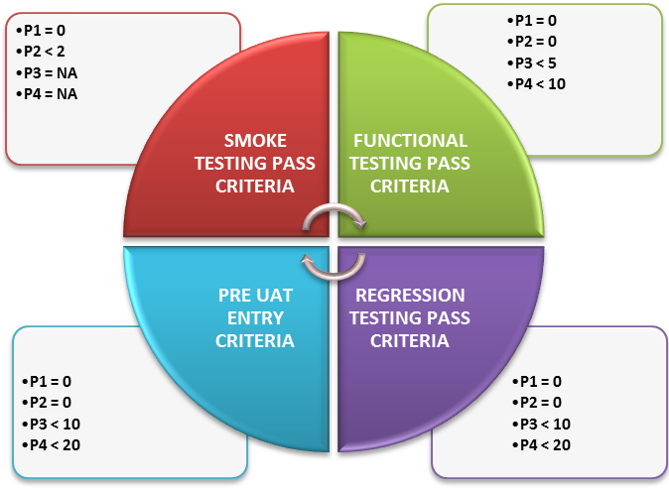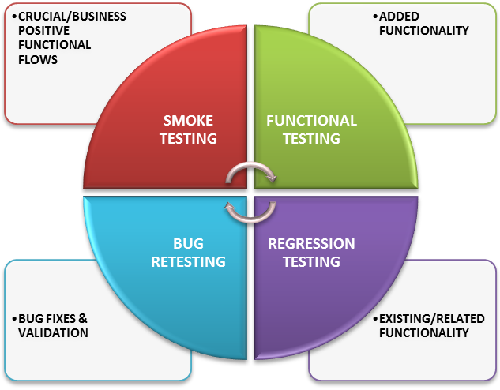

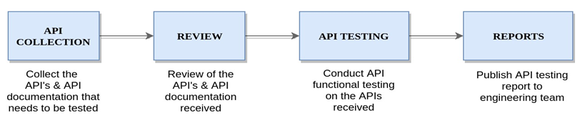

TEST PHASES/STLC
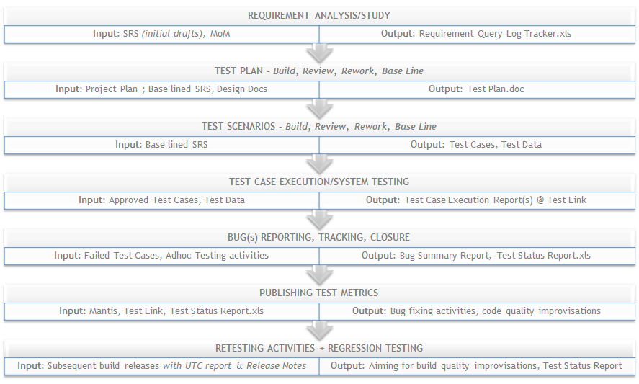

TEST CASE EXECUTION
QA shall execute all the approved test cases and shall apply all the testing techniques as mentioned in section 5.2. Test Case Execution report shall be generated for each test iteration conducted and the below steps are involved:
- Updating the bug(s) in bug tracking tool with screenshots, steps, comments/fields and others as required
- Mapping Bugs with the Test Case ID's in the bug tracking tool
- Publishing MoM of bug scrubs/triages or other meetings attended
- Updating the test cases in google docs/tool/excel with PASS/FAIL/ NO RUN status
- Updating the test cases in google docs/tool/excel with comments and bug id's
- Raising the bugs found during Smoke testing
- Raising the bugs found during retesting
- Raising the bugs found during Regression testing
- Raising the bugs found during Functional testing
- Raising the bugs found during Adhoc testing
- Publishing Test Exit Report, during major RC (release candidate) builds to customer/client

TEST TOOLS

S.No | Testing Tool | Description
1 | Mantis/JIRA/Bugzilla | Bug Reporting & Tracking Tool
2 | Test Link | Test Case Management Tool
3 | MS Office/Emails | Documentation/Communication/Reporting
4 | Postman, Newman | API Testing Tool & Reporting Tool

TEST SCHEDULE
This will be decided in consultation with the project manager and the development team:
Testing Task(s) | Work | Begin | End
Smoke Testing
Retesting
API/Integration Testing
Negative Testing
Interoperability Testing
Performance/Load Testing
Security/Vulnerability Testing

BUG TRACKING & REPORTING
Mantis is used for Bug Reporting & Tracking by the QA team.

Bug Tracking Tool URL: <mention the tool URL here>

BUG SUMMARY REPORT
A bug report describes the bugs in the Application under Test (AUT). The bugs will be reported using a standard format with the following information captured in Project Open tool:

- Bug ID
- Bug Discovery date
- Last Accessed/Modified Date
- Test Platform
- Assigned To
- Reporter
- Status
- Resolution
- Bug Summary
- Steps To Reproduce
- Build Version
- Severity
- Priority
- Comment(s)

BUG LIFE CYCLE
The below work-flow chart explains the Bug Life Cycle:
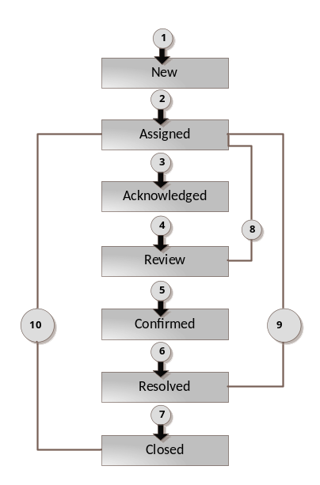

BUG(s) CLASSIFICATION
Bugs detected by Test Engineer are classified based upon the impact caused & significance of the bug. This helps in Bug fixing and Prioritization activities.

Priority | Priority Type | Description
P1 | Show Stoppers | Business Impact is Very High ; Requires immediate bug fix without which, next internal/external release can’t be initiated
P2 | Major Functional Bugs | Business Impact is High ; Requires bug fix without which, next internal/external release can’t be initiated
P3 | Minor Functional Bugs | Business Impact is Normal; Delay in bug fix is acceptable ; next internal/external release may be initiated without this bug fix
P4 | Cosmetic Bugs/UI/UX/Text related | Business Impact is Low ; Delay in bug fix is acceptable ; next internal/external release may be initiated without this bug fix

TEST STATUS REPORTING
On a daily basis, QA team maintains & updates Test Status Reporting with the following data captured:

- Test Execution Details
- Bug Analysis
  - Chart: Bug Distribution across Modules
  - Chart: Bug Status – Status wise
  - Chart: Bug Trend – Status wise
  - Chart: Closed Bugs – Priority wise
  - Chart: Test Case Design Status
  - Chart: Test Case Execution Status
- Test Environment Details
- Tasks conducted Today
- Tasks for Tomorrow
- Risk(s)/Issue(s)/Concern Areas

TEST ENVIRONMENT
- Network Connectivity accessed
- Web client application URL
- OS & Browser Tested

RELEASE CRITERIA

TEST PASS & FAIL CRITERIA
A business test case is declared as PASS if the expected result matches with actual result else the same is declared as FAIL and a bug is raised in Project Open for development team’s attention.

TEST SUSPENSION & RESUMPTION CRITERIA
S. No | Suspension Criteria | Resumption Criteria
1 | Network unavailability | When the network connection is restored
2 | When a P1/P2 bug is introduced into AUT, that obstructs further testing | When the bug fix is made available to the test team
3 | When the released build is unstable with P1 crashes (>5) & more than 25 Functional/S2 bugs discovered | When a stable build is released to QA, with all the raised bugs fixed
4 | Unavailability of updated RFP with QA | Signed off RFP is made available
5 | Unavailability of latest build for more than 2 weeks to the Testing team | Latest build is made available for testing

EXTERNAL BUILD RELEASE
There has to be 0 (zero) P1, P2 bugs in the project application for an external release to be initiated.

UAT CRITERIA
S. No | Entry Criteria | Exit Criteria
1 | System Testing exit criteria is met | Business requirements are met in the release candidate
2 | UAT Testing Environment readiness | No P1+P2 defects are discovered during client UAT
3 | UAT Test Cases are ready & signed off by Project team | All UAT Test Cases are executed and have passed

TEST DELIVERABLES

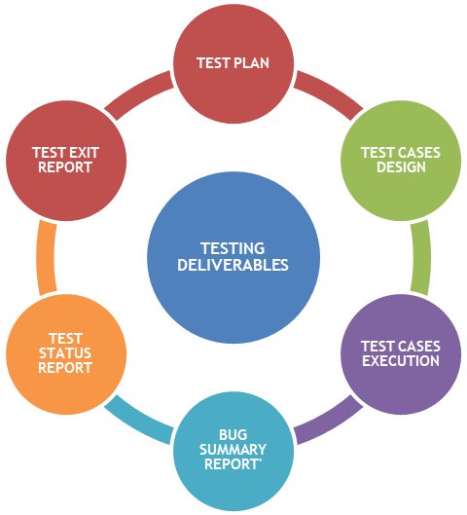

ROLES & RESPONSIBILITIES

S.No. | Role | Responsibility
1 | Test Engineer | - Requirement study  - Test Case Design  - Test Data Design  - Test Case Execution  - Bug Reporting & Tracking  - Attending client calls/discussions
2 | Test Lead | - Requirements Analysis & Understanding  - Test Plan Design/Review/Rework  - Test Cases Design/Review/Rework  - Test Cases Execution & Validations, if any  - Produce High Level and Detailed Test Conditions  - Submits Test Status Report, on a weekly basis  - Tracking and monitoring the testing activities  - Training/Mentoring the Test Engineers  - Report testing status during regular standup meetings  - Co-ordinate, review & ensure signoff of Test Deliverables, by PM  - Follow up’s with development team  - Attending client calls/discussions, as required  - Ensure Entrance criteria are achieved prior to Sanity/System/UAT Test start  - Ensure Exit criteria are achieved prior to System Test signoff
3 | Project Manager | - Publish/Review/Update project plan to Testing Team  - Resolve RFP conflicts & publish the updated RFP  - Approval/Sign Off of all Test Deliverables  - Planning for Test resources for the project  - Planning and estimating for Testing effort  - Interacting with Test Manager for Test related events  - Provide Test Schedule to allocated Test resources  - Regular interaction with the Test team to know the project whereabouts & health status  - Arranging for Bug Triage & standup meetings between Dev & Testing Team members  - Involving Testing Team in client interactions with Dev team  - Decide the release candidate quality, before initiating for client UAT

ANNEXURE(s)
S. No. | Name | Signature | Date

